**Body Copy with Background Image:**

* This seems to be the “Bulleted List / Dashed List” module in PDP template

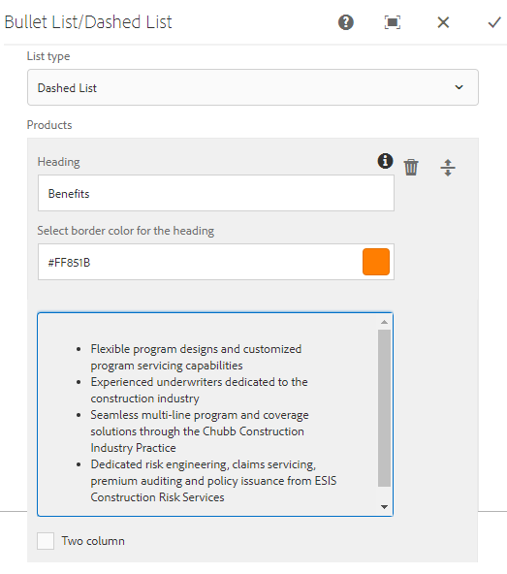

* I don’t think we need “List type” field. Based on the content entered in the RFT, it can be rendered as is (with a hyphen or a bullet). It can also be a plain paragraph text also and hence forcing for dash or bullet is not correct
* A field for Sub heading is missing as in <http://chubb-v2-dev.acegrpaccess.com/us-en/about-chubb-demo/product-detail-page.aspx>
* “Select border Color for the heading” – Rename this as “Horizontal Separator color” and it should be a drop down field
* When I add plain paragraph text in the current module and select “Two Column”, it is not accepting the column selection and always giving the output in single column (<http://diusd-lapp0098.chubbdigital.net:4504/editor.html/content/chubb-digital/na/us-en/product-detail-page.html>). Only when I add bullet to this paragraph, then the 2 column layout is working
  + Either with a single RTF field, we should achieve the 2 column layout even for plain text.
  + OR, we should ask for Layout Type with Single column / 2 Column as options. If one column is selected then show one RTF field and if 2 column is selected, then show 2 RTF fields (Left column content / Right column content).

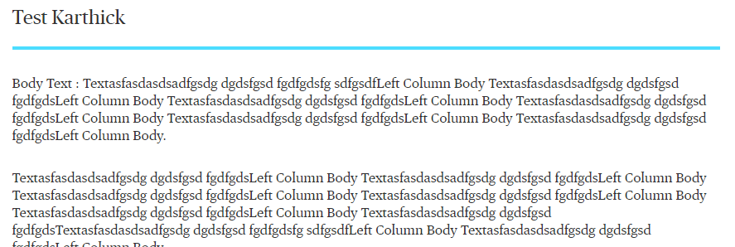

* A field for Background Image should be added as in <http://chubb-v2-dev.acegrpaccess.com/us-en/about-chubb-demo/product-detail-page.aspx> (Optional field). If this field is selected then the Decorative image text box will become mandatory.

**Related Content:**

<http://diusd-lapp0098.chubbdigital.net:4504/editor.html/content/chubb-digital/na/us-en/product-detail-page.html>

* “Align to Right” – I think this field is not needed since the alignment is controlled by the “Body Copy container” that is holding this module. With or without this selection, I don’t see a significance
* “Should display as Resource Module” – I don’t know the significance of this option. If it is to show the content in either stacked or column layout, then we should have a drop down field called “Layout Type” and have “Column” / “Stacked” as options to select
* “Icon Background Color” should be a dropdown selection
* “Link” – Update this field as Title
* “Heading Redirection Path” – Rename it as “Link”
* “Link to be opened in Same or New window” – Rename it as “Link Target”
* “Sub Link Title” – Rename this as “Pretitle” and move it above the Title field
  + This field doesn’t need any link selection (as in Crown peak)

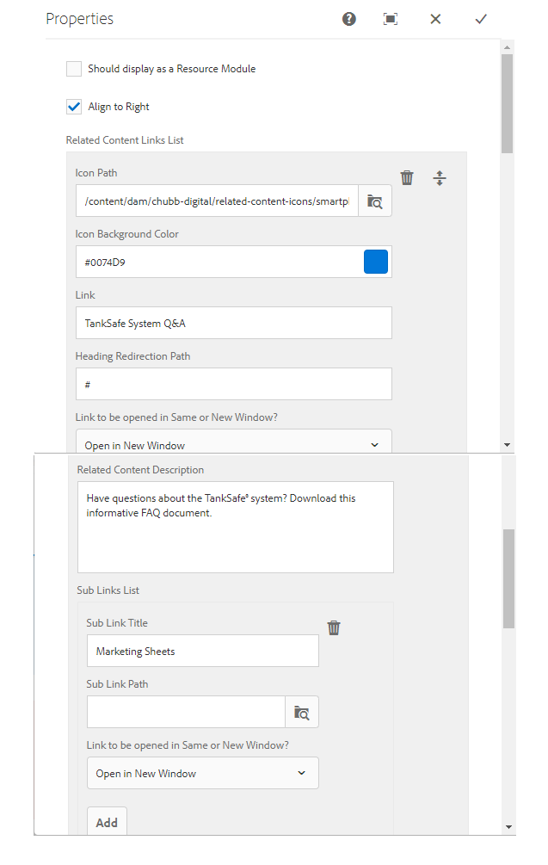

**Card Component:**

Combo of Section Header, Card and Text module gives the desired output - <http://diusd-lapp0098.chubbdigital.net:4504/editor.html/content/chubb-digital/na/us-en/product-detail-page.html>

* Accessibility Tab can be removed as this is empty
* A new field for “Link Target” should be added after Link field
* “Card Border Color” – Rename to “Top Border Color” with drop down options

